**Regression and Time Series Analysis**

***Project Proposal***

Amaan Vora (RUID – 216005070)

Jahnavi Shah (RUID – 218009800)

Noopur Singh (RUID – 220008221)

Ganesh Raj K (RUID –219001760)

***“Analysis and Prediction of Varied Financial Indexes post the Russia – Ukraine War”***

The one event that shaped 2022 into the year it’s been was undoubtedly Russia’s invasion of Ukraine on the 7th of February, with over 200,000 soldiers. This marked the decline of our current supply chain management as Ukraine was responsible for a major portion of the EU’s trade. Being in the top 5 of the world’s top exporters of grain and food items, Ukraine’s collapse of crop supply affected trade across the world. The EU as a whole was significantly affected by the war, as Russia halted access to major oil pipelines and blew up important trade routes at the borders it shared with Ukraine. These events demonstrably changed major stock markets and indexes across the world.

Our aim with this project is to explore this change in the stock markets and indexes. We plan to exercise tested time-series analyses and regression models to understand the markets and indexes in its current form, analyze the events throughout this year that shaped up these indexes to present day, and present our own prediction based on historical data for the next financial quarter. For this, we would be using a routine stock index dataset containing information about the daily stock indexes of companies – including their low, high, open and close price, their stock volume and an adjusted close value for extra measure.

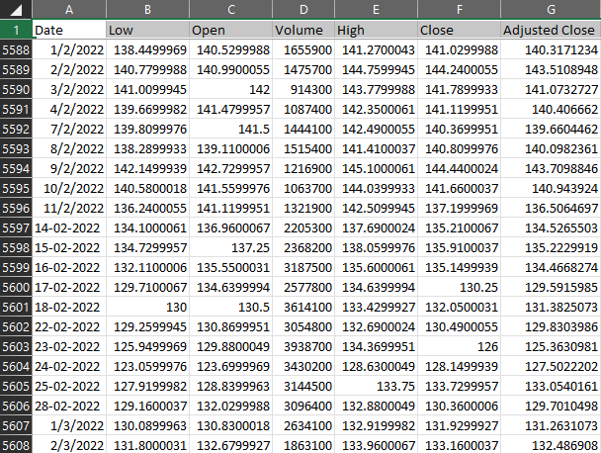

*A snapshot of our dataset*

|  |  |
| --- | --- |
| Programming Language | Technologies Used |
| R programming | Time Series Analysis  Linear Regression |